**Community Website**

**A PROJECT REPORT**

***In partial fulfillment for the award of the degree***

***Of***

**BACHELOR OF TECHNOLOGY**

**IN**

**COMPUTER SCIENCE AND ENGINEERING**

***Under the Guidance of***

**MAHENDRA DATTA**

***Project Carried Out At***



**Ardent Computech Pvt Ltd (An ISO 9001:2008 Certified)**

**CF-137, Sector - 1, Salt Lake City, Kolkata - 700 064**

***Submitted By***

**ANAMITRA GHOSH**

**CHAYAN CHAKRABORTY**

**DIBYENDU DUTTA**

**KRISHNA KAMAL MANDAL**

**SHINCHAN CHOWDHURY**



**Saroj Mohan Institute of Technology**

**(Degree Engineering Division)**

**Guptipara * Hooghly *712512**

**In association with**

***(Note: All entries of the proforma of approval should be filled up with appropriate and complete information. Incomplete proforma of approval in any respect will be summarily rejected.)***

1. Title of the Project: **Community Website**

2. Project Members: 1. **Anamitra Ghosh**, 2**. Chayan Chakraborty** 3**. Dibyendu Dutta,**

**4. Krishna Kamal Mandal 5. Shinchan Chowdhury.**

3. Name and Address of the Guide: **MR. MAHENDRA DATTA**

Subject Matter Expert & Assistant Technical Head (Advanced Java Domain)

Ardent Computech Pvt Ltd (An ISO 9001:2008 Certified)

CF-137, Sector - 1, Salt Lake City, Kolkata - 700 064

PhD**\***  M.Tech.**\*** B. E\***/**B. Tech* MCA**\*** M.Sc.**\***

Y

4. Educational Qualification of the Guide:

5. Working / Training experience of the Guide: **3 Years**

6. Project Version Control History

|  |  |  |  |
| --- | --- | --- | --- |
| **Version** | **Primary Authors** | **Description of Version** | **Date Completed** |
| Final | **Anamitra Ghosh, Chayan Chakraborty, Dibyendu Dutta, Krishna Kamal Mandal, Shinchan Chowdhury** | Project Report | 10th July, 2018 |

1. 2.

3. 4.

5.

Signatures of Team Members Signature of Approval

Date: Date:

**For Office Use Only Mr. MAHENDRA DATTA**

Project Proposal Evaluator

**Approved**

**Not Approved**

**Project Responsibility Form**

**Community Website**

|  |  |  |  |  |  |  |  |  |  |  |  |  |  |  |  |  |  |  |  |  |  |  |
| --- | --- | --- | --- | --- | --- | --- | --- | --- | --- | --- | --- | --- | --- | --- | --- | --- | --- | --- | --- | --- | --- | --- |
| |  |  |  |  | | --- | --- | --- | --- | | GROUP NO. | SL.NO. | NAME OF MEMBER | RESPONSIBILITY | | 1 | 1 | Anamitra Ghosh | System Analysis & Documentation | | 2 | Chayan Chakraborty | Design, Testing and Maintenance | | 3 | Dibyendu Dutta | System Analysis ,Testing | | 4 | Krishna Kamal Mandal | Project Leader , Design, Coding & Testing | | 5 | Shinchan Chowdhury | PPT, Documentation, Presentation |   Each group member must participate in project development and developing the ideas for the required elements. Individual group members will be responsible for completing tasks which help to finalize the project and the performance. All group members must be assigned a task. | |  | | --- | |  | |

Date:

Name of the Students

1. Anamitra Ghosh
2. Chayan Chakraborty
3. Dibyendu Dutta
4. Krishna Kamal Mandal
5. Shinchan Chowdhury

Signatures of the students

a. b.

c. d.

e.

**DECLARATION**

We hereby declare that the project work being presented in the project proposal entitled

**“(Community Website)”** in partial fulfilment of the requirements for the award of the degree of **BACHELOR OF TECHNOLOGY IN COMPUTER SCIENCE AND ENGINEERING** at **ARDENT COMPUTECH PVT. LTD, SALTLAKE, KOLKATA, WEST BENGAL,** is an authentic work carried out under the guidance of **MR. MAHENDRA DATTA**. The matter embodied in this project work has not been submitted elsewhere for the award of any degree of our knowledge and belief.

Date:

Name of the Students

1. Anamitra Ghosh
2. Chayan Chakraborty
3. Dibyendu Dutta
4. Krishna Kamal Mandal
5. Shinchan Chowdhury

Signature of the students

a.

b.

c.

d.

e.



**Ardent Computech Pvt Ltd (An ISO 9001:2008 Certified)**

**CF-137, Sector - 1, Salt Lake City, Kolkata - 700 064**

**CERTIFICATE**

This is to certify that this proposal of minor project entitled **“COMMUNITY WEBSITE”** is a record of bona fide work, carried out by **1. ANAMITRA gHOSH2. cHAYAN cHAKRABORTY3. dIBYENDU dUTTA 4. kRISHNA KAMAL MANDAL 5. sHINCHAN CHOIWDHURY** under my guidance at **Ardent Computech Pvt Ltd**. In my opinion, the report in its present form is in partial fulfilment of the requirements for the award of the degree of **BACHELOR OF TECHNOLOGY IN COMPUTER SCIENCE AND ENGINEERING** and as per regulations of the **Ardent*®.*** To the best of my knowledge, the results embodied in this report, are original in nature and worthy of incorporation in the present version of the report.

**Guide / Supervisor**

**_____________________________________________________________**

**Mr. MAHENDRA DATTA**

Subject Matter Expert & Assistant Technical Head (Java Domain)

Ardent Computech Pvt Ltd (An ISO 9001:2008 Certified)

CF-137, Sector - 1, Salt Lake City, Kolkata - 700 064

**ACKNOWLEDGEMENT**

Success of any project depends largely on the encouragement and guidelines of many others. We take this sincere opportunity to express our gratitude to the people who have been instrumental in the successful completion of this project work.

Our heartfelt thanks to **Mr. SUJIT RAHA** HOD of Department of Computer Science, Saroj Mohan Institute of Technology, for providing us the opportunity to develop the project at Ardent Computech Pvt. Ltd.

We would like to show our greatest appreciation to **Mr. Mahendra Datta**, Project Manager at Ardent, Kolkata. We always feel motivated and encouraged every time by his valuable advice and constant inspiration; without his encouragement and guidance this project would not have materialized.

We wish to express our deep sense of gratitude to our internal guides, Professors of Saroj Mohan Institute of Technology, for their abled guidance and useful suggestions, which helped us in completing the project work in time.

Words are inadequate in offering our thanks to the other trainees, project assistants and other members at Ardent Computech Pvt. Ltd. for their encouragement and cooperation in carrying out this project work. The guidance and support received from all the members and who are contributing to this project, was vital for the success of this project.

**TABLE OF CONTENTS**

|  |  |  |
| --- | --- | --- |
| **S.NO.** | **Name of the Topic** | **Page No.** |
| **1.** | **Company Profile** | **9** |
|  |  |  |
| **2.** | **Introduction** | **11-13** |
| 2.1 | Objective | 13 |
| 2.2 | Scope | 13 |
|  |  |  |
| **3.** | **System Analysis** | **14-21** |
| 3.1 | Identification of Need | 15 |
| 3.2 | Feasibility Study | 16 |
| 3.3 | Work flow | 17 |
| 3.4 | Functional Requirements | 19 |
| 3.5 | Non-Functional Requirements | 20 |
| 3.6 | Hardware and Software Requirements | 21 |
|  |  |  |
| **4.** | **System Design** | **22-45** |
| 4.1 | Data Flow Diagram(DFD) | 23 |
| 4.2 | Entity-Relationship Diagram | 28 |
| 4.3 | Use-case Diagram | 31 |
| 4.4 | Modularization Details | 33 |
| 4.6 | User Interface Design | 35 |
|  |  |  |
| **5.** | **Implementation & Testing** | **46-56** |
| 5.1 | Introduction | 47 |
| 5.2 | Objectives of Testing | 48 |
| 5.3 | Test Cases | 48 |
| 5.4 | White Box Testing | 50 |
| 5.5 | Black Box Testing | 50 |
| 5.6 | Output Testing | 50 |
| 5.7 | User Acceptance Testing | 54 |
| 5.8 | Integration Testing | 56 |
|  |  |  |
| **6.** | **System Security Measures** | **57-58** |
| 6.1 | Database Security Measures | 58 |
| 6.2 | System Security Measures | 58 |
| 6.3 | Limitations | 58 |
|  |  |  |
| **7.** | **Conclusion** | **59** |
|  |  |  |
| **8.** | **Future Scope & Further Enhancements** | **60** |
|  |  |  |
| **9.** | **Bibliography/References** | **61** |

1. **ARDENT COMPUTECH PVT. LTD.**

Ardent Computech Private Limited is an ISO 9001-2008 certified Software Development Company in India. It has been operating independently since 2003. It was recently merged with ARDENT TECHNOLOGIES.

Ardent Technologies

ARDENT TECHNOLOGIES is a Company successfully providing its services currently in UK, USA, Canada and India. The core line of activity at ARDENT TECHNOLOGIES is to develop customized application software covering the entire responsibility of performing the initial system study, design, development, implementation and training. It also deals with consultancy services and Electronic Security systems. Its primary clientele includes educational institutes, entertainment industries, resorts, theme parks, service industry, telecom operators, media and other business houses working in various capacities.

Ardent Collaborations

ARDENT COLLABORATIONS, the Research Training and Development Department of ARDENT COMPUTECH PVT LTD is a professional training Company offering IT enabled services & industrial trainings for B-Tech, MCA, BCA, MSc and MBA fresher’s and experienced developers/programmers in various platforms. Summer Training / Winter Training / Industrial training will be provided for the students of B. TECH, M. TECH, MBA, MCA and BCA only. Deserving candidates may be awarded stipends, scholarships and other benefits, depending on their performance and recommendations of the mentors.

# Associations

Ardent is an ISO 9001:2008 company. It is affiliated to National Council of Vocational Training (NCVT), Directorate General of Employment & Training (DGET), Ministry of Labor & Employment, and Government of India.

Community Website

1. **INTRODUCTION**

**What is Black Board?**

Black Board is a question-and-answer site where questions are asked, answered, edited, and organized by its community of users. Black Board requires users to register with their real names rather than an Internet pseudonym although verification of names is not required, false names can be reported by the community. Black Board supports various features to moderate content posted by users. The majority of content moderation is done by the users, though staff can also intervene.

**HISTORY**

An online community, also called an internet community, is a [virtual community](https://en.wikipedia.org/wiki/Virtual_community) whose members interact with each other primarily via the Internet. For many, online communities may feel like home, consisting of a "family of invisible friends". Those who wish to be a part of an online community usually have to become a member via a specific site and necessarily need an internet connection. An online community can act as an [information system](https://en.wikipedia.org/wiki/Information_system) where members can post, comment on discussions, give advice or collaborate. Commonly, people communicate through [social networking sites](https://en.wikipedia.org/wiki/Social_networking_sites), [chat rooms](https://en.wikipedia.org/wiki/Chat_room), [forums](https://en.wikipedia.org/wiki/Internet_forum), e-mail lists and discussion boards. "a virtual community is defined as an aggregation of individuals or business partners who interact around a shared interest, where the interaction is at least partially supported and/or mediated by technology and guided by some protocols or norms". Some research has looked at the users of online communities. [Amy Jo Kim](https://en.wikipedia.org/w/index.php?title=Amy_Jo_Kim&action=edit&redlink=1) has classified the rituals and stages of online community interaction and called it the 'Membership life cycle'.

A 2001 McKinsey & Company study showed that only 2% of transaction site customers returned after their first purchase, while 60% of new online communities’ users began using and visiting the sites regularly after their first experiences. Online communities have changed the game for retail firms, forcing them to change their business strategies. Companies have to network more, adjust computations, and alter their organizational structures. Because consumers and customers in all fields are becoming accustomed to more interaction and engagement online, adjustments must be considered made in order to keep audiences intrigued.

**FEATURES**

**Black Board** is **question-and-answer website** or platform. We use the internet every day to online shopping, social networking, chatting, watch movies, learn new technologies. For most of the internet users, it's like a guide or the place where they can **find answers** of all kind of question. And of course, it's the best place to find answers without going anywhere. Some question and answers sites are playing a great role in helping users to ask anything and **find answers**. Like every successful website, Black Board become very famous because of its awesome features and usability’s. For people who don't ever heard about Black Board, the search engine is the only way but a Black Board user knows that every answer of any question can be found on Black Board.

**Add Answers**: If you can provide an informative and helpful answer regarding the particular question then you can add answer via add button placed at the bottom of the last answer.

**Your Activity Feed**: It shows the most recent activities of users according to the topics that have to choose during registration.

**ADVANTAGES**

In Black Board, almost every topic is available for all type of audience. A user can select some topics according to their interest so they can ask a question and provide answers about that topic. It's the best place to increase your knowledge in the desired field or you can make the better decisions by taking advice from the expert. Black Board can make the things possible which can't be done easily anywhere else on the internet.

It's like the instructor for people who seeks to learn new technologies or subjects. Here you can make a connection with people who are an expert in the particular technology or working professional. It's a medium to connect with the people from around the world and huge community of answers seekers and people who love to share knowledge and answer the question.

**2.1 OBJECTIVE**

1. You can demonstrate your expertise on almost any topic.
2. You can get insights from experts in any industry.
3. You can give direct answers to anyone asking about your business, products, or services.
4. You can share content from other websites (including your own) in topic-focused boards on your profile.
   1. **SCOPE**

It's the sort of question that looks quite legitimate – and it's the sort of question you might find on one of the hottest sites on the internet right now, [quora.com](http://quora.com/).

Quora is a simple question-and-answer site. Whatever your question, type it in the search box and, if there isn't already an answer there, users will pile in and attempt to answer it. Information is organized more like Wikipedia than [Google](https://www.theguardian.com/technology/google), with answers prioritized by how useful they are, but the site uses Twitter-style following to track the best contributors.

System Analysis

**3.1 IDENTIFICATION OF NEED**

System analysis is a process of gathering and interpreting facts, diagnosing problems and the information to recommend improvements on the system. It is a problem-solving activity that requires intensive communication between the system users and system developers. System analysis or study is an important phase of any system development process. The system is studies to the minutest detail and analyzed. The system analyst plays the role of the interrogator and dwells deep into the working of the present system. The System is viewed as a whole and the input to the system are identified. The outputs from the organization are traced to the various processes. System analysis is concerned with becoming aware of the problem, identifying the relevant and Decisional variables, analysis and synthesizing the various factors and determining an optimal or at least a satisfactory solution or program of action.

A detailed study of the process must be made by various techniques like interviews, questionnaires etc. The data collected by these sources must be scrutinized to arrive to a conclusion. The conclusion is an understanding of how the system functions. This system is called the existing system. Now the existing system is subjected to close study and problem area are identified. The designer now functions as a problem solver and tries to sort out the difficulties that the enterprise faces. The solutions are given as proposals. The proposal is then weighed with the existing system analytically and the best one is selected. The proposal is presented to the user for an endorsement by the user. The proposal is reviewed on user request and suitable changes are made. This is loop that ends as soon as the user is satisfied with proposal.

**3.2 FEASIBILITY STUDY**

Feasibility study is made to see if the project on completion will serve the purpose the organization for the amount of work.

Effort and the time that spend on it. Feasibility study lets the developer foresee the future of the project and the usefulness. A feasibility study of a system proposal is according to its workability, which is the impact on the organization, ability to meet their user needs and effective use of resources. Thus, when a new application is proposed it normally goes through a feasibility study before it is approved for development.

The document provides the feasibility of the project that is being designed and lists various area that were considered very carefully during the feasibility study of this project such as Technical, Economic and operational feasibilities.

**3.3 WORK FLOW**

This Document plays a vital role in the development life cycle (SDLC) as it describes the complete requirement of the system. It is meant for use by the developers and will be the basic during testing phase. Any changes made to the requirements in the future will have to go through formal change approval process.

WATER FALL MODEL was being chosen because all requirements were known beforehand and the objective of our software development is the computerization/automation of an already existing manual working system.

**Communicated Requirements**

**Requirements Specification**

**Design Specification**

**Executable Software Modules**

**Integrated Software Product**

**Delivered Software Product**

**Changed Requirements**

**Requirements Engineering**

**Design**

**Programming**

**Integration**

**Delivery**

**Maintenance**

**Product**

**Product**

**Input**

**Output**

**Process**

**Fig: Water Fall Model**

The developer is responsible for:

* Developing the system, which meets the SRS and solving all the requirements of the system?
* Demonstrating the system and installing the system at client's location after the acceptance testing is successful.
* Submitting the required user manual describing the system interfaces to work on it and also the documents of the system.
* Conducting any user training that might be needed for using the system.
* Maintaining the system for a period of one year after installation.

**3.4 FUNCTIONAL REQUIREMENTS**

**Modules:**

The modules used in this software are as follows:

* **Registration:** This page contains the account number, name, C/O,

Email, password, confirm password, D.O.B, gender, mobile, address, language, qualification.

* **Login:** This module is for registered users to login. The **user** has the authority to Add, Delete, and Update the answers etc.
* **Main:** This page contains an overview of Black Board from other user will get the questions & answers & also be able to view the others opinions.
* **Feedbacks:** This page contains name, email address, website, your message which is used by the costumer to give the suggestion.

**3.5NON-FUNCTIONAL REQUIREMENTS**

* **Usability Requirement**: The system shall allow the users to access the system from any browsers, no special training is required. The system user friendly and the system is written in simple English.
* **Availability Requirement**: The system is available 100% for the user and is used by 24 hours a day and 365days a year. The system shall be operational 24 hours a day and 7 days a week.
* **Accuracy**: The system should accurately provide real time information taking into consideration various issues. The system shall provide 100% access reliability.
* **Performance Requirement**: The information is refreshed at regular intervals depending upon whether some updates have occurred or not. The system shall respond the member in less than 45 seconds.
* **Security Requirement**: System will use a secured database and the system will have different users and each user has different types of constraints. Only admins have the rights to update database information of other users.
* **Reliability Requirement**: The system has to be 100% reliable due to the importance of data and the damages that can be caused by incorrect data. The system will run 7 days a week and 24 hours a day.

**3.6 HARDWARE and SOFTWARE REQUIREMENTS**

**HARDWARE REQUIREMENTS**

* Computer that has a 1.6GHz or faster processor
  + 1 GB (32 Bit) or 2 GB (64 Bit) RAM (Add 512 MB if running in a virtual machine)
  + HDD 20 GB Hard Disk Space and Above Hardware Requirements5400 RPM hard disk drive
  + DirectX 9 capable video card running at 1024 x 768 or higher-resolution display
  + DVD-ROM Drive

**SOFTWARE REQUIREMENTS**

* WINDOWS OS (XP/Vista/ 7 / 8 / 8.1 / 10)
* Microsoft Visual C++ 2012 Redistributable
* .Net Framework 4.0
* Java plugin

System design

**4.1 DATA FLOW DIAGRAM**

|  |
| --- |
| A Data Flow Diagram (DFD) is a diagram that describes the flow of data and the processes that change data throughout a system. A structured analysis and design tool that can be used for flowcharting in place of or in association with information. Oriented and process oriented system flowcharts. When analysts prepare the Data Flow Diagram, they specify the user needs at a level of detail that virtually determines the information flow into and out of the system and the required data resources. This network is constructed by using a set of symbols that do not imply physical implementations. The Data Flow Diagram reviews the current physical system, prepares input and output specification, specifies the implementation plan etc. |
| |  |  |  |  |  |  | | --- | --- | --- | --- | --- | --- | | Four basic symbols are used to construct data flow diagrams. They are symbols that represent data source, data flows, and data transformations and data storage. The points at which data are transformed are represented by enclosed figures, usually circles, which are called nodes.   |  | | --- | | **DATA FLOW DIAGRAM SYMBOLS**    Source or Destination of Data    Data Flow    Process    Storage | |  |  | | **Steps to Construct Data Flow Diagram**  Four Steps are generally used to construct a DFD.   * Process should be named and referred for easy reference. Each name should be representative of the reference. * The destination of flow is from top to bottom and from left to right. * When a process is distributed into lower level details they are numbered. * The names of data stores, sources and destinations are written in capital letters.   Rules for constructing a Data Flow Diagram-   * Arrows should not cross each other. * Squares, Circles, Files must bear a name. * Decomposed data flow squares and circles can have same names. * Draw all data flow around the outside of the diagram.   **DATA FLOW DIAGRAM**  Level 0:  **USER**  Level 1:    **USER** |  | | | Level 2:  **Question Answers**    **Signup** |  | |  |  | |  |  | |  |  | |  |  | |  |
| USER  **Feedback**  **4.2ENTITY RELATIONSHIP DIAGRAM**   |  | | --- | | In [software engineering](http://en.wikipedia.org/wiki/Software_engineering), an **entity–relationship model** (**ER model**) is a [data model](http://en.wikipedia.org/wiki/Data_modeling) for describing the data or information aspects of a business domain or its process requirements, in an abstract way that lends itself to ultimately being implemented in a [database](http://en.wikipedia.org/wiki/Database) such as a [relational database](http://en.wikipedia.org/wiki/Relational_database). The main components of ER models are [entities](http://en.wikipedia.org/wiki/Entities) (things) and the relationships that can exist among them.  However, variants of the idea existed previously, and have been devised subsequently such as super type and subtype data entities and commonality relationships.  An entity–relationship model is a systematic way of describing and defining a business process. The process is modeled as components (*entities*) that are linked with each other by *relationships* that express the dependencies and requirements between them, such as: *one building may be divided into zero or more apartments, but one apartment can only be located in one building.* Entities may have various properties (*attributes*) that characterize them. Diagrams created to represent these entities, attributes, and relationships graphically are called entity–relationship diagrams.  An ER model is typically implemented as a [database](http://en.wikipedia.org/wiki/Database). In the case of a [relational database](http://en.wikipedia.org/wiki/Relational_database), which stores data in tables, every row of each table represents one instance of an entity. Some data fields in these tables point to indexes in other tables; such pointers represent the relationships.  The [three schema approach](http://en.wikipedia.org/wiki/Three_schema_approach) to [software engineering](http://en.wikipedia.org/wiki/Software_engineering) uses three levels of ER models that may be developed.  An [entity](http://en.wikipedia.org/wiki/Entity) may be defined as a thing capable of an independent existence that can be uniquely identified. An entity is an abstraction from the complexities of a domain. When we speak of an entity, we normally speak of some aspect of the real world that can be distinguished from other aspects of the real world.  A relationship captures how entities are related to one another. Relationships can be thought of as [verbs](http://en.wikipedia.org/wiki/Verb), linking two or more nouns.  Cardinality constraints are expressed as follows:   * a double line indicates a *participation constraint*, [totality](http://en.wikipedia.org/wiki/Total_relation) or [subjectivity](http://en.wikipedia.org/wiki/Surjective_function) : all entities in the entity set must participate in *at least one* relationship in the relationship set; * an arrow from entity set to relationship set indicates a [key constraint](http://en.wikipedia.org/wiki/Unique_key), i.e. [infectivity](http://en.wikipedia.org/wiki/Injective_relation): each entity of the entity set can participate in *at most one* relationship in the relationship set; * A thick line indicates both, i.e. [objectivity](http://en.wikipedia.org/wiki/Bijection): each entity in the entity set is involved in *exactly one* relationship. * An underlined name of an attribute indicates that it is a [key](http://en.wikipedia.org/wiki/Unique_key): two different entities or relationships with this attribute always have different values for this attribute.     **E.R DIAGRAM**  **QUESTIONS**  **ASK**  **SIGNUP**  **1 M**  **1 1 1**  **GIVES**  **GIVES**  **HAS**  **1 M M**  **ANSWERS**  **FEEDBACK** | |  |  | |  |  | |  |  | |  |  | |  |
|  |  |
|  |  |
|  |  |
| **4.3 MODULARIZATION DETAILS**  As Modularization has gained increasing focus from companies outside its traditional industries of aircraft and automotive, more and more companies turn to it as strategy and product development tool. I intend to explain the importance aspects of modularization and how it should be initiated within a company. After determining the theoretical steps of modularization success described in literature, I intend to conduct a multiple case study of companies who have implemented modularization in order to find how real-world modularization was initiated and used to improve the company’s competitiveness. By combining theory and practical approach to modularization I will derive at convergence and divergence between theoretical implementation to modularization and real-world implementation to modularization. This gives a valuable input for both implantations in companies as well as new aspects to be further. |  |
|  |  |

**DATA INTEGRITY AND CONSTRAINTS**

Data integrity is normally enforced in a [database system](http://en.wikipedia.org/wiki/Database_system) by a series of [integrity constraints](http://en.wikipedia.org/wiki/Integrity_constraints) or rules. Three types of integrity constraints are an inherent part of the relational data model: entity integrity, referential integrity and domain integrity:

* [*Entity integrity*](http://en.wikipedia.org/wiki/Entity_integrity) concerns the concept of a [primary key](http://en.wikipedia.org/wiki/Primary_key). Entity integrity is an integrity rule which states that every table must have a primary key and that the column or columns chosen to be the primary key should be unique and not null.
* Concerns the concept of a [foreign key](http://en.wikipedia.org/wiki/Foreign_key). The referential integrity rule states that any foreign-key value can only be in one of two states. The usual state of affairs is that the foreign-key value refers to a primary key value of some table in the database. Occasionally, and this will depend on the rules of the data owner, a foreign-key value can be [null](http://en.wikipedia.org/wiki/Null_(SQL)). In this case we are explicitly saying that either there is no relationship between the objects represented in the database or that this relationship is unknown.
* *Domain integrity* specifies that all columns in a relational database must be declared upon a defined domain. The primary unit of data in the relational data model is the data item. Such data items are said to be non-decomposable or atomic. A domain is a set of values of the same type.

**4.4 DATABASE DESIGN**

A database is an organized mechanism that has capability of storing information through which a user can retrieve stored information in an effective and efficient manner. The data is the purpose of any database and must be protected.

The database design is two level processes. In the first step, user requirements are gathered together and a database is designed which will meet these requirements as clearly as possible. This step is called information Level design and it is taken independent of any individual DBMS.

In the following snapshots we display the way we have used Oracle XE 11.20.2018 Server as the back-end RDBMS for our project and the various entities that have been used along with their table definition and table data.

**DATA DICTIONARY**

**1. User registration, question & answer table definition**

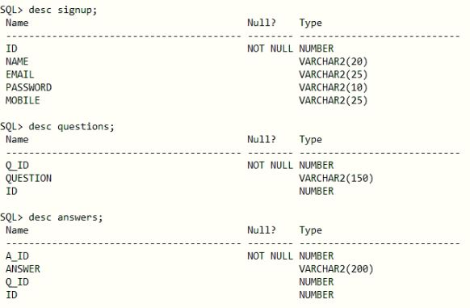

**2.Employee table data**

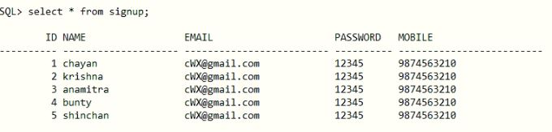

**4.5 USER INTERFACE DESIGN**

**User interface design (UID)** or **user interface engineering** is the [design](http://en.wikipedia.org/wiki/Design) of [user interfaces](http://en.wikipedia.org/wiki/User_interface) for [machines](http://en.wikipedia.org/wiki/Machine) and [software](http://en.wikipedia.org/wiki/Software), such as computers, [home appliances](http://en.wikipedia.org/wiki/Home_appliance), [mobile devices](http://en.wikipedia.org/wiki/Mobile_device), and other [electronic devices](http://en.wikipedia.org/wiki/Electronics), with the focus on maximizing the [user experience](http://en.wikipedia.org/wiki/User_experience). The goal of user interface design is to make the user's interaction as simple and efficient as possible, in terms of accomplishing user goals ([user-centered design](http://en.wikipedia.org/wiki/User-centered_design)).

Good user interface design facilitates finishing the task at hand without drawing unnecessary attention to it. [Graphic design](http://en.wikipedia.org/wiki/Graphic_design) and typography are utilized to support its [usability](http://en.wikipedia.org/wiki/Usability), influencing how the user performs certain interactions and improving the aesthetic appeal of the design; design aesthetics may enhance or detract from the ability of users to use the functions of the interface. The design process must balance technical functionality and visual elements (e.g., [mental model](http://en.wikipedia.org/wiki/Mental_model)) to create a system that is not only operational but also usable and adaptable to changing user needs.

Interface design is involved in a wide range of projects from computer systems, to cars, to commercial planes; all of these projects involve much of the same basic human interactions yet also require some unique skills and knowledge. As a result, designers tend to specialize in certain types of projects and have skills centered on their expertise, whether that be [software design](http://en.wikipedia.org/wiki/Software_design), user research, [web design](http://en.wikipedia.org/wiki/Web_design), or [industrial design](http://en.wikipedia.org/wiki/Industrial_design).

**SNAPSHOTS**

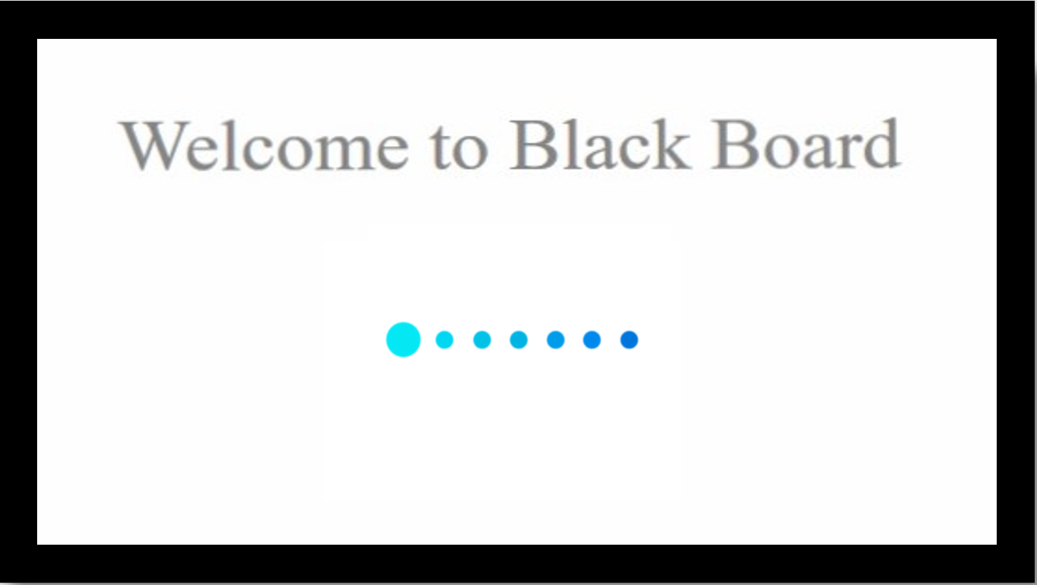

**HOME PAGE: -**

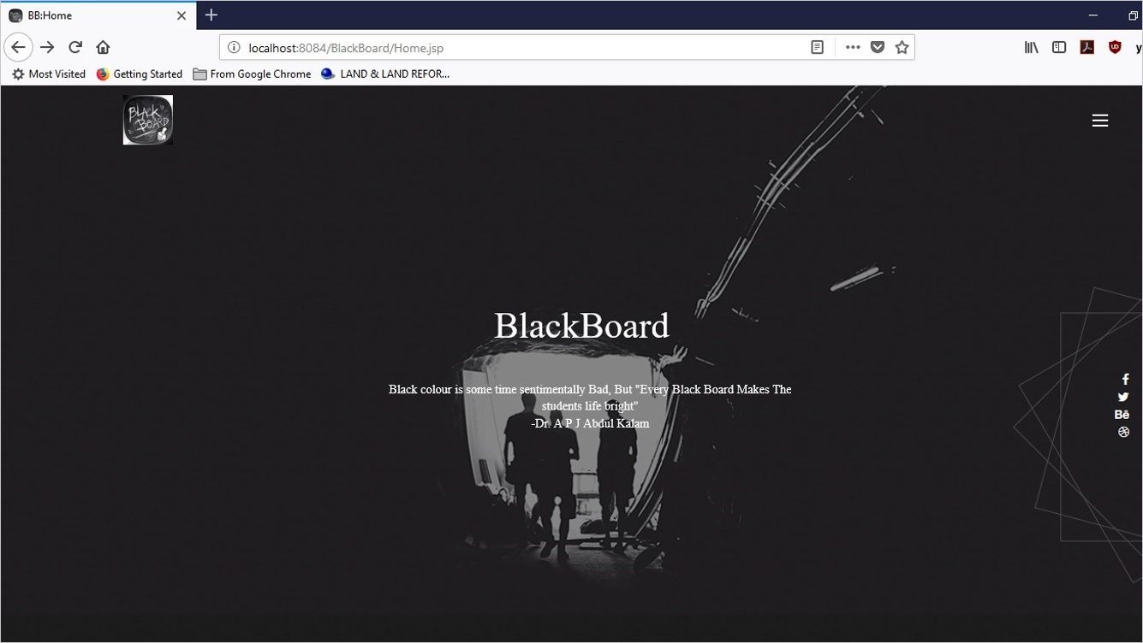

**CODING**

%--

Document : Home

Created on : Jul 4, 2018, 11:24:22 PM

Author : Krishna Kamal

--%>

<%@page contentType="text/html" pageEncoding="UTF-8"%>

<!DOCTYPE html>

<html class="no-js" lang="">

<head>

<meta http-equiv="Content-Type" content="text/html; charset=UTF-8">

<meta charset="utf-8">

<meta http-equiv="X-UA-Compatible" content="IE=edge,chrome=1">

<style>

.loader {

border: 16px solid #f3f3f3;

border-radius: 50%;

border-top: 16px solid black;

border-right: 16px solid black;

border-bottom: 16px solid black;

border-left: 16px solid white;

width: 120px;

height: 120px;

-webkit-animation: spin 2s linear infinite;

animation: spin 2s linear infinite;

**LOGIN:-**

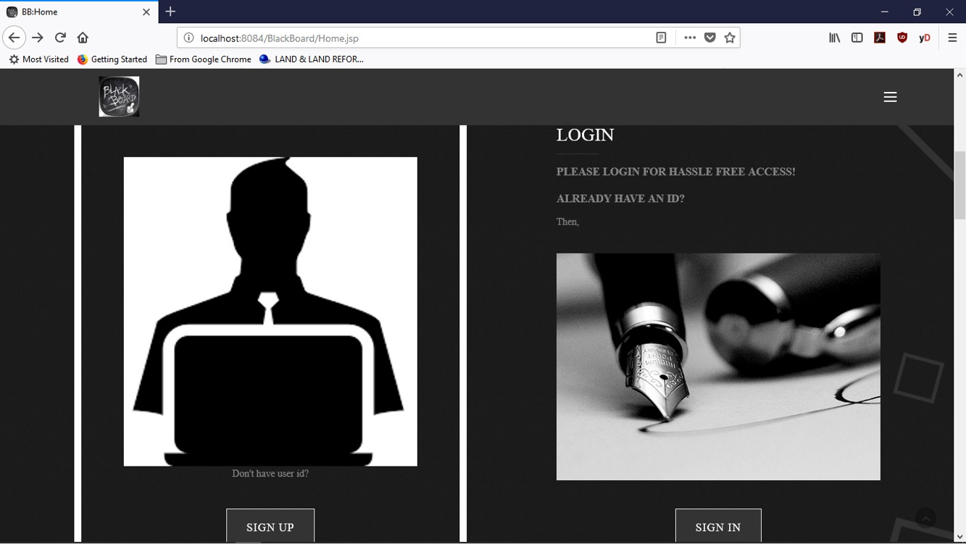

**CODING**

<div class="col-sm-5 col-sm-offset-1">

<div class="single_abt single_tobias single_tobias_text wow fadeInRight">

<h3 class="text-uppercase">Login</h3>

<div class="separator"></div>

<h4 class="text-uppercase">Please Login for Hassle Free Access!</h4>

<h4 class="text-uppercase">Already have an id?</h4>

<p>Then,</p>

<br>

<img src="assets/images/pluma.jpg" alt="" />

<center>

<!-- Trigger of Modal -->

<button type="button" data-toggle="modal" class="btn btn-primary margin-top-40" data-target="#myModal">Sign In</button></center>

<!-- Modal -->

<div class="modal fade" id="myModal">

<center><div class="modal-dialog modal-sm">

<div class="modal-content">

<!-- Modal Header -->

<div class="modal-header">

<h4 class="modal-title">Sign In Here!</h4>

<button type="button" class="close" data-dismiss="modal">&times;</button>

</div>

<!-- Modal body -->

<div class="modal-body">

<form action="Login_check" method="post">

<input type="email" name="email" placeholder="Email" required="required" height="35px" width="20px">

<input type="password" name="pass" placeholder="Password" required="required" height="25px" width="20px">

<button type="Submit" class="btn btn-primary">Sign In</button>

</form>

</div>

**AFTER LOGIN:-**

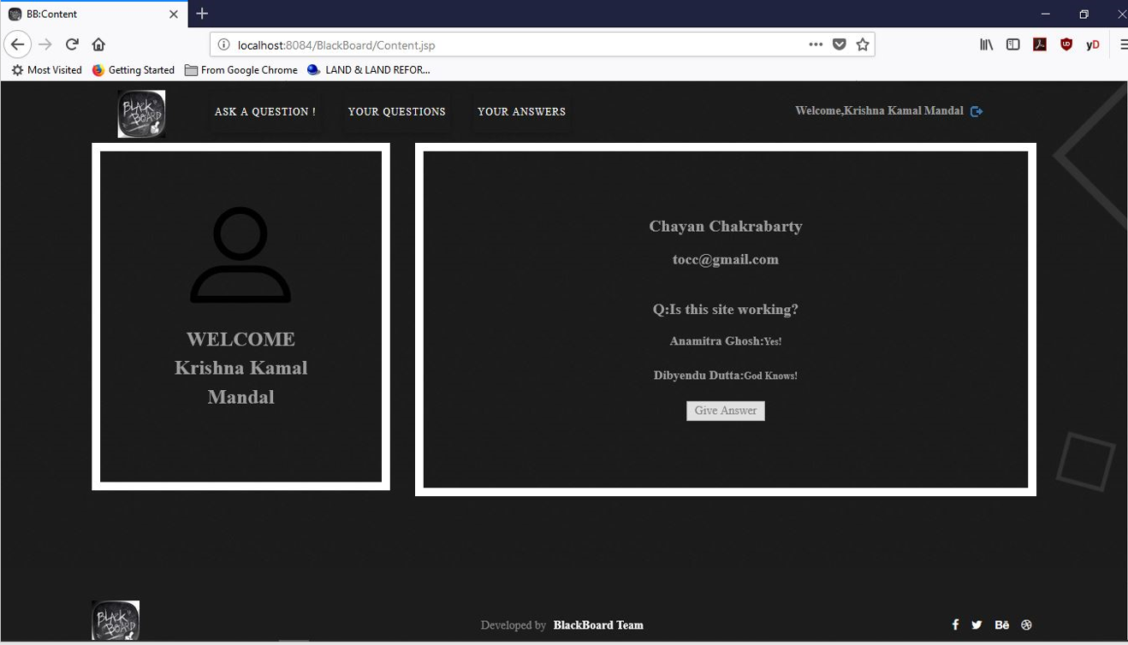

**CODING**

<script src="https://ajax.googleapis.com/ajax/libs/jquery/1.11.3/jquery.min.js"></script>

<script src="http://maxcdn.bootstrapcdn.com/bootstrap/3.3.5/js/bootstrap.min.js"></script>

<%

String p_id=session.getAttribute("ss_id").toString();

String nm=session.getAttribute("ss_nm").toString();%>

<!--Old browser JS-->

<div class="container">

<div class="div-menu">

<header class="cd-header">

<a href="" class="brand-logo text-left"><img src="assets/images/logo.jpg" alt="" /></a>

<button type="button" style="font-size:12px" class="btn btn-info, btn-sm" data-toggle="modal" data-target="#myModal2">YOUR QUESTIONS</button>

<!-- Modal -->

<div class="modal fade" id="myModal2" role="dialog" >

<div class="modal-dialog">

<!-- Modal content-->

<div class="modal-content">

<div class="modal-header">

<button type="button" class="close" data-dismiss="modal">X</button>

<h4 class="modal-title"> Your Questions:</h4>

</div>

<div class="modal-body">

<p><textarea <textarea name="qus" rows="4" cols="20" readonly="readonly" disabled="disabled">

<%--

Class.forName("oracle.jdbc.driver.OracleDriver");

String url="jdbc:oracle:thin:@localhost:1521:XE";

Connection con=DriverManager.getConnection(url,"krish", "man");

String sql="select *from questons where id=?";

PreparedStatement ps=con.prepareStatement(sql);

ps.setString(1, p_id);

ResultSet rs=ps.executeQuery();

while(rs.next())

{

rs.getObject(2);

}

**FEEDBACK: -**

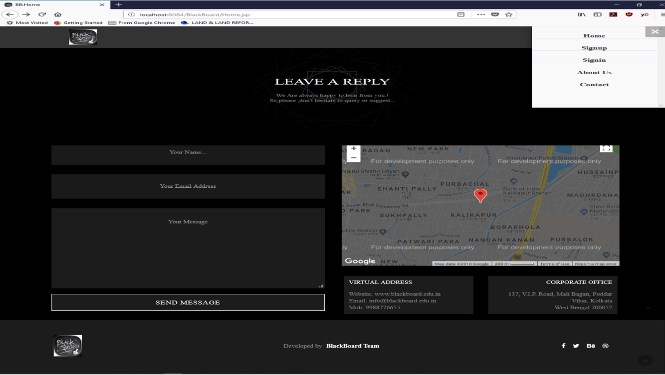

**WHY RESPONSIVE WEBSITE?**

We have designed a fully responsive website with the help of bootstrap and jQuery. Now a day’s smartphones, tablets and other gadgets are most widely used and every user would fancy all web activity to be done through those gadgets. Hence, we have come forward with this idea of a fully responsive website with a responsive menu which automatically fits the website in any screen size and readjusts its components as and when required, be it smartphone, tablet, phablet or any other gadget.

IMPLEMENTATION

AND

TESTING

**IMPLEMENTATION AND TESTING**

A software system test plan is a document that describes the objectives, scope, approach and focus of software testing effort. The process of preparing a test plan is a usual way to think the efforts needed to validate the acceptability of a software product. The complete document will help people outside the test group understand the "WHY" and "HOW" product validation. It should be through enough to be useful but not so through that no one outside the test group will read it.

**5.1 INTRODUCTION**

Testing is the process of running a system with the intention of finding errors. Testing enhances the integrity of a system by detecting deviations in design and errors in the system. Testing aims at detecting error-prone areas. This helps in the prevention of errors in a system. Testing also adds value to the product by conforming to the user requirements.

The main purpose of testing is to detect errors and error-prone areas in a system. Testing must be thorough and well-planned. A partially tested system is as bad as an untested system. And the price of an untested and under-tested system is high.

The implementation is the final and important phase. It involves user-training, system testing in order to ensure successful running of the proposed system. The user tests the system and changes are made according to their needs. The testing involves the testing of the developed system using various kinds of data. While testing, errors are noted and correctness is the mode.

**5.2 OBJECTIVES OF TESTING**

The objective our test plan is to find and report as many bugs as possible to improve the integrity of our program. Although exhaustive testing is not possible, we will exercise a broad range of tests to achieve our goal. Our user interface to utilize these functions is designed to be user-friendly and provide easy manipulation of the tree. The application will only be used as a demonstration tool, but we would like to ensure that it could be run from a variety of platforms with little impact on performance or usability.

**Process Overview**

The following represents the overall flow of the testing process:

1. Identify the requirements to be tested. All test cases shall be derived using the current Program Specification.

2. Identify which particular test(s) will be used to test each module.

3. Review the test data and test cases to ensure that the unit has been thoroughly verified and that the test data and test cases are adequate to verify proper operation of the unit.

4. Identify the expected results for each test.

5. Document the test case configuration, test data, and expected results.

6. Perform the test(s).

7. Document the test data, test cases, and test configuration used during the testing process. This information shall be submitted via the Unit/System Test Report (STR).

8. Successful unit testing is required before the unit is eligible for component integration/system testing.

9. Unsuccessful testing requires a Bug Report Form to be generated. This document shall describe the test case, the problem encountered, its possible cause, and the sequence of events that led to the problem. It shall be used as a basis for later technical analysis.

10. Test documents and reports shall be submitted. Any specifications to be reviewed, revised, or updated shall be handled immediately.

**5.3 TEST CASES**

A test case is a document that describe an input, action, or event and expected response, to determine if a feature of an application is working correctly. A test case should contain particular such as test case identifier, test condition, input data

Requirement expected results. The process of developing test cases can help find problems in the requirement or design of an application, since it requires completely thinking through the operation of the application.

**TESTING STEPS**

**Unit Testing**

Unit testing focuses efforts on the smallest unit of software design. This is known as module testing. The modules are tested separately. The test is carried out during programming stage itself. In this step, each module is found to be working satisfactory as regards to the expected output from the module.

**Integration Testing**

Data can be lost across an interface. One module can have an adverse effect on another, sub functions, when combined, may not be linked in desired manner in major functions. Integration testing is a systematic approach for constructing the program structure, while at the same time conducting test to uncover errors associated within the interface. The objective is to take unit tested modules and builds program structure. All the modules are combined and tested as a whole.

**Validation**

At the culmination of the integration testing, Software is completely assembled as a package. Interfacing errors have been uncovered and corrected and a final series of software test begin in validation testing. Validation testing can be defined in many ways, but a simple definition is that the validation succeeds when the software functions in a manner that is expected by the customer. After validation test has been conducted, one of the three possible conditions exists.

a) The function or performance characteristics confirm to specification and are accepted.

b) A deviation from specification is uncovered and a deficiency lists is created.

c) Proposed system under consideration has been tested by using validation test and found to be working satisfactory.

|  |  |  |  |
| --- | --- | --- | --- |
| **Tested By:** | | Krishna Kamal Mandal | |
| **Test Type** | | Unit Testing | |
| **Test Case Number** | | 1 | |
| **Test Case Name** | | User Registration | |
| **Test Case Description** | | The user should enter his/ her accurate information so that he/she can able to go for the further options. The test case will check the application for the same since a user can only login with the correct user id and password. | |
| **Item(s) to be tested** | | | |
| 1 | Verification of the user id and password with the record in the database. | | |
| **Specifications** | | | |
| **Input** | | | **Expected Output/Result** |
| 1. Correct User id and password 2. Incorrect Id or Password | | | 1. Successful login 2. Failure Message |

|  |  |  |  |
| --- | --- | --- | --- |
| **Tested By:** | | Dibyendu Dutta | |
| **Test Type** | | Unit Testing | |
| **Test Case Number** | | 2 | |
| **Test Case Name** | | User Login | |
| **Test Case Description** | | A new user will enter his details in the registration form and the credentials will be checked by the validators used in the form. After all the credentials are validated then only the form will be submitted and data will be stored in the database | |
| **Item(s) to be tested** | | | |
| 1 | Required fields in the form are not empty, validation of proper credentials | | |
| **Specifications** | | | |
| **Input** | | | **Expected**  **Output/Result** |
| * 1. User id, name, password, phone, address, email.   2. Empty field, Invalid entry | | | 1. Successful registration 2. Failure Message |

**5.4 WHITE BOX TESTING**

In white box testing, the UI is bypassed. Inputs and outputs are tested directly at the code level and the results are compared against specifications. This form of testing ignores the function of the program under test and will focus only on its code and the structure of that code. Test case designers shall generate cases that not only cause each condition to take on all possible values at least once, but that cause each such condition to be executed at least once. To ensure this happens, we will be applying Branch Testing. Because the functionality of the program is relatively simple, this method will be feasible to apply.

Each function of the binary tree repository is executed independently; therefore, a program flow for each function has been derived from the code.

**5.5 BLACK BOX TESTING**

Black box testing typically involves running through every possible input to verify that it results in the right outputs using the software as an end-user would. We have decided to perform Equivalence Partitioning and Boundary Value Analysis testing on our application.

System Testing

The goals of system testing are to detect faults that can only be exposed by testing the entire integrated system or some major part of it. Generally, system testing is mainly concerned with areas such as performance, security, validation, load/stress, and configuration sensitivity. But in our case well focus only on function validation and performance. And in both cases, we will use the black-box method of testing.

**5.6 OUTPUT TESTING**

After performing the validation testing, the next step is output testing of the proposed system, since no system could be useful if it does not produce the required output in a specific format. The output format on the screen is found to be correct. The format was designed in the system design time according to the user needs. For the hardcopy also; the output comes as per the specified requirements by the user. Hence output testing did not result in any correction for the system.

**5.7User Acceptance Testing**

User acceptance of a system is the key factor for the success of any system. The system under consideration is tested for the user acceptance by constantly keeping in touch with the prospective system users at the time of developing and making changes whenever required.

This is done in regard to the following point:

a) Input Screen Design

b) Output Screen Design

c) Format of reports and other outputs.

**5.8 INTEGRATION TESTING**

Software testing is always used in association with verification and validation. In the testing phase of this project our aim is to find the answer to following two questions.

* Whether the software matches with the specification (i.e. Process base) to verify the product.
* Whether this software in one client what wants (i.e. product base) to validate the product.
* Unit testing and integration testing has been carried out to find the answer to above questions. In unit testing each individual module was test to find any unexpected behaviour if exists. Later all the module was integrated and flat file was generated.

**FUNCTIONAL TESTING**

These are the points concerned during the stress test:

* Nominal input: character is in putted in the place of digits and the system has to flash the message "Data error"
* Boundary value analysis: exhaustive test cases have designed to create an output report that produces the maximum (and minimum) allowable number of table entries.

SOFTWARE SYTEM Attributes

**6.1 DATABASE SECURITY**

System security measure is meant to be provided to make your system reliable and secured from unauthorized user may create threats to the system. So you should follow some security measures. We have used security levels in database level at system level.

**6.2 SYSTEM SECURITY**

If we talk about the system security in our proposed system, we have implemented with the help of maintain the session throughout the system’s use. Once a user has logged out than he/she will not be able to perform any task before signing back again.

A high level of authentic login is given to the system so this is a very tedious task to enter without authorization and authentication.

**6.3 LIMITATIONS**

* Since it is an online project, customers need internet connection to use it.
* People who are not familiar with computers can’t use this software.
* Customer must have an account to ask a question or answer one.

**7. CONCLUSION**

**Black board** is a place to gain and share knowledge. It’s a platform to ask questions and connect with people who contribute unique insights and quality answers.

**8. FUTURE SCOPE AND FURTHER ENHANCEMENTS**

In future, we would like to keep working on this project and make new additions to provide users with more advanced features and more detailed information. We have set our sights on the following additions in future-

1. More attractive interface.
2. More responsive site.
3. Live video streaming tutorial.
4. Secure site.

**9.REFERENCES**

1. <https://en.wikipedia.org/wiki/Online_community>
2. <https://www.webarxsecurity.com/webarx-community>
3. <http://www.ntu.edu.sg/home/ehchua/programming/howto/References.html>
4. <https://developer.mozilla.org/en-US/docs/Web/JavaScript/Reference>
5. <https://getbootstrap.com/docs/4.1/getting-started/introduction>
6. <https://bugs.chromium.org/p/chromium/issues/detail?id=175502>

THANK YOU